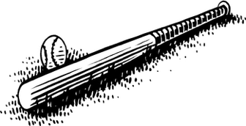
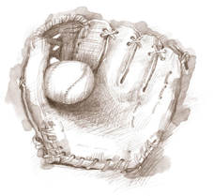
Registration for Summer Baseball and Softball

$35.00 Registration Fee (if received prior to 3-13-26) Size: Youth = XS S M L XL
$20.00 T-Shirt (same royal shirt as last year) Adult = S M L XL XXL
Name (on back of shirt) _________________________ Please circle size needed.

Male or Female (circle one please)

Name: _________________________ Birth Date:_____________________

Parents: _______________________Mom Cell #: ___________Dad Cell#___________

E- Mail address________________________________________________________

Grade: __________ Paid by Cash______ Check_______
Preschool & Kindergarten - T-Ball
1st & 2nd Grade - Coach Pitch
3rd Grade - Supervised Pitch Ball
4th & 5th Grade - Peewee
6th & 7th Grade - Midget

______ I would be interested in being a volunteer coach for _________ grade.
Adult Coach T-Shirt Size____________ (Free for volunteer coaches)
Extra T-Shirts can be ordered ($20.00). Just write what size and if you want a name on it.

Coaches will notify you when practices will start. Pants will be the responsibility of the player. The pants need to be the color GRAY and can be purchased at any store that carries sporting goods.
Entry deadline is on or before March 13th, in order for the park board to get an idea of how many teams Northwood will have participating in league play. This is critical in the fact that the schedule is compiled at the league meeting. Please return your registration form along with the proper fee amount to the City Hall, by 3/13/2026.

Parents:
We do not hold the City of Northwood responsible for accidental loss of any kind and the City of Northwood accepts no responsibility for injuries incurred. Each individual is responsible for his/her own insurance coverage.

_____________________________
Parent Signature


Northwood Park & Rec
Thank you from your Park Board Members: Jesse Renteria, Matt Tufte, Wade Flattum, Shana Brunsvold, Jennifer Johnson-Krotzer.

